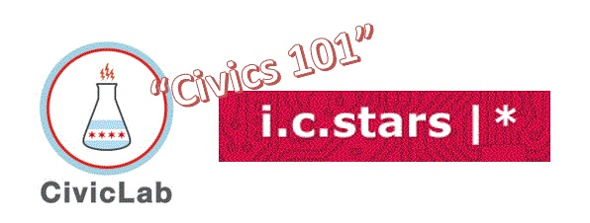
i c stars Cycle 51 – “Civics 101” – Class #2 – 9/30/22

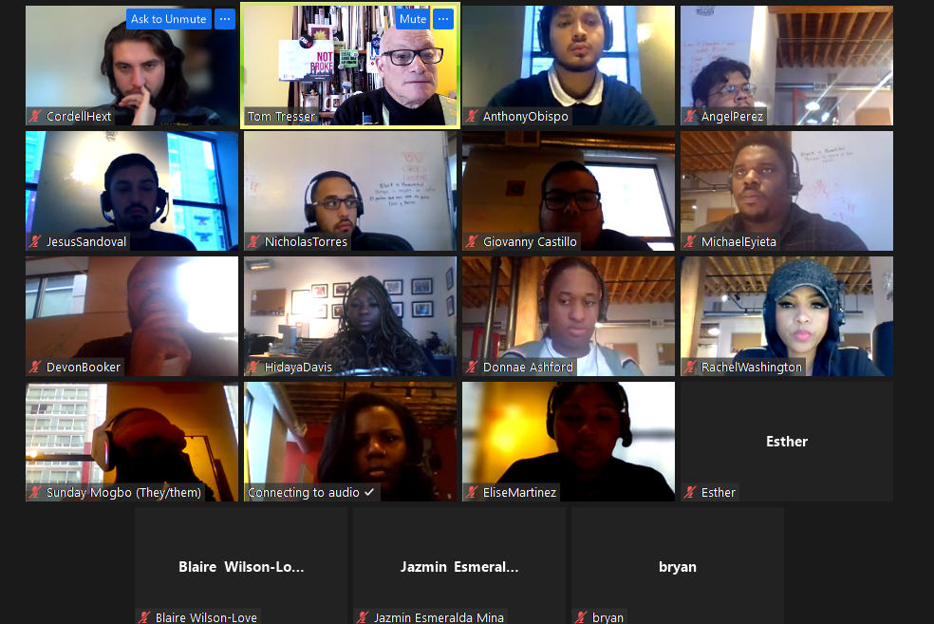

Music: “Heroes” by David Bowie, suggested by Giovanny - https://www.youtube.com/watch?v=lXgkuM2NhYI

Building Empathy JamBoard = https://tinyurl.com/C51-Empathy

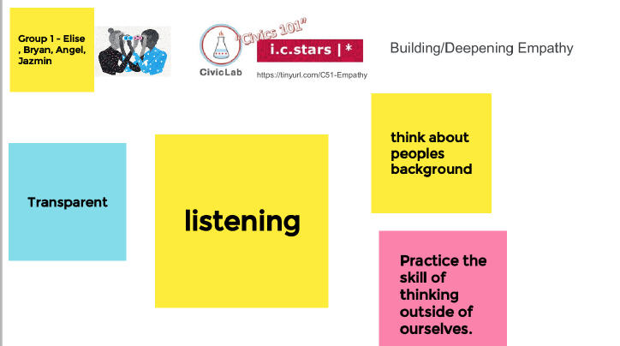 | 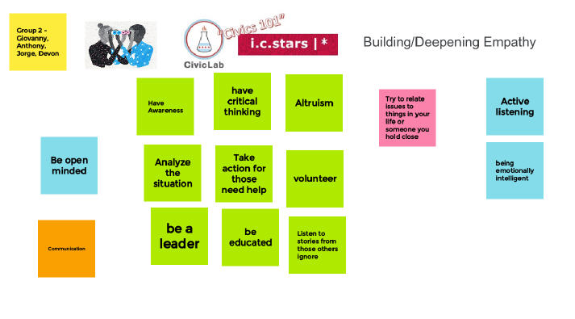
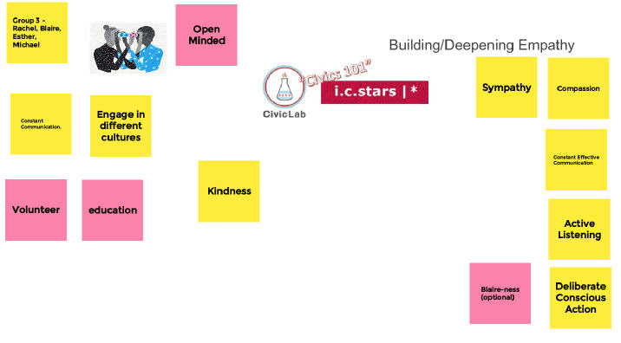 | 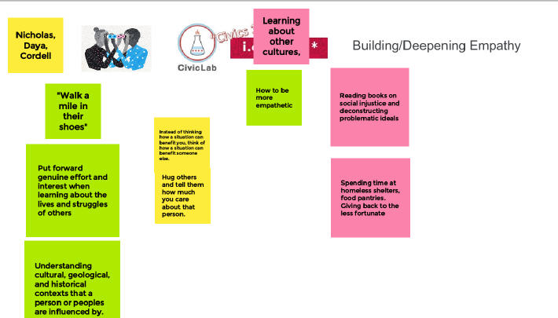
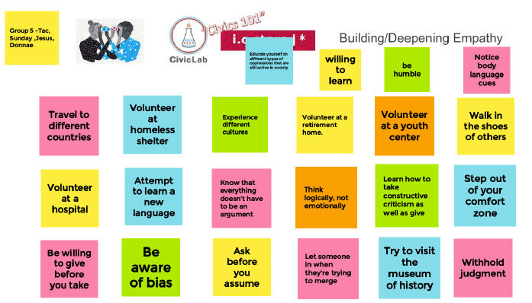

- Sunday - There are SYSTEMIC ISSUES. That is the PRIORITY - THAT is where the ACCOUNTABILITY is…
Number 1 Empathy Building Skill?
- Listening/learning
- Listening helps you get UNSTUCK
- Can't learn unless you learn and unlearn
- Listen to oppressed people - listen to marginalized people - listen to people who you have power over
- Take accountability on what you DO control

Servant Leadership
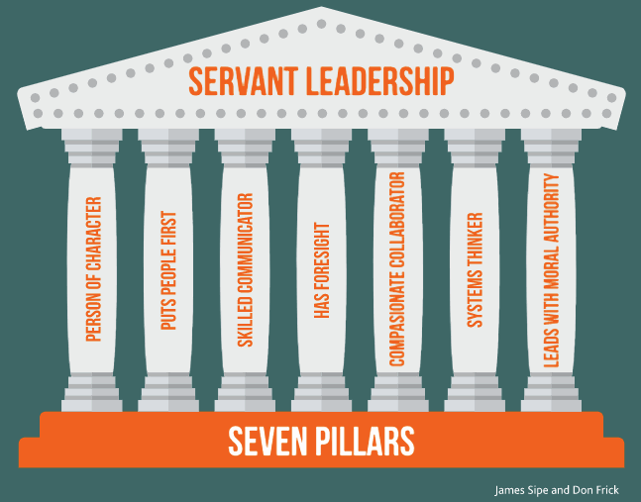
- A leader who is also a servant
- A leader who is granted leadership status BY the people she leads
- From the Archbishop Tutu interview: A servant leader is/does…
- One leads FOR the sake of others
- An element of sacrifice – one is not "feathering your nest"
- He mentions saintly figures - but we all can lead in this way...
- The good leader "inspires" others - how do we do that?
- If you are "inspired" what happens? What inspires you?
- The leader represents the best - the aspirations - the hopes of the people.

Civic Brain
- JamBoards -> http://tinyurl.com/C51-CivicBrain-JB

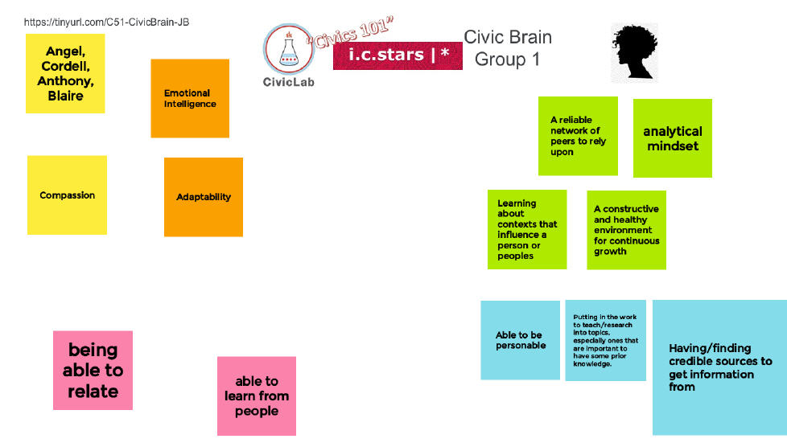 | 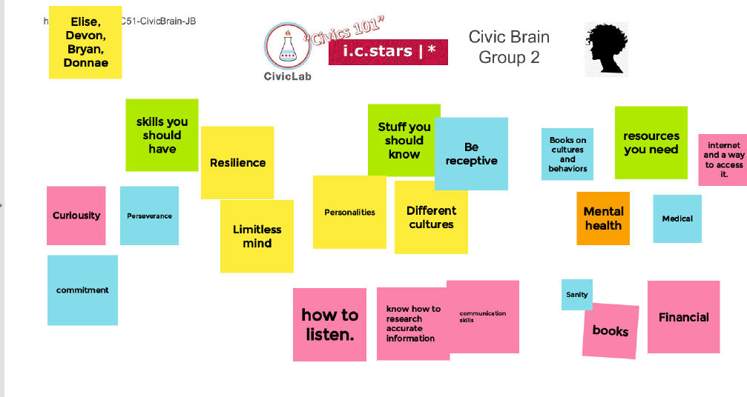
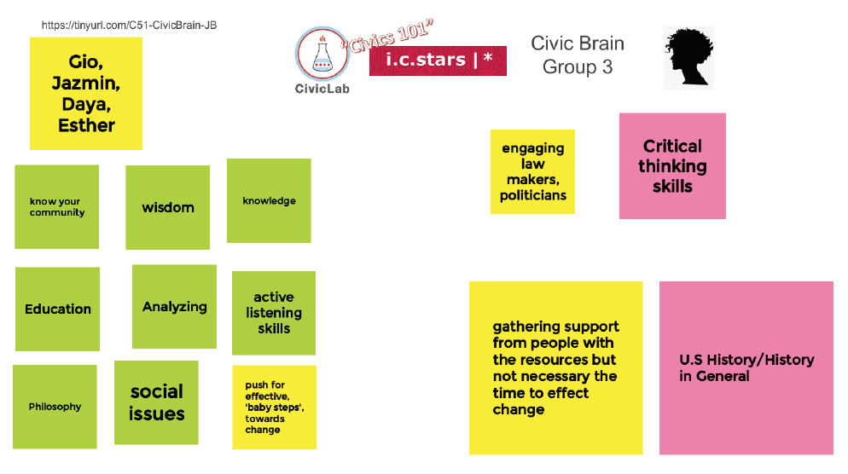 | 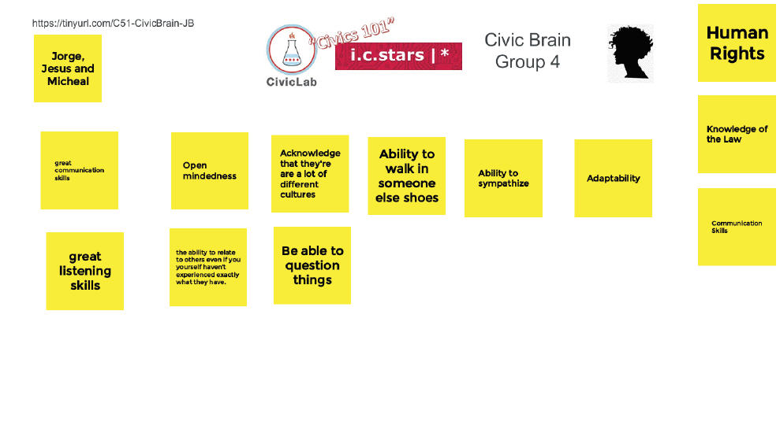
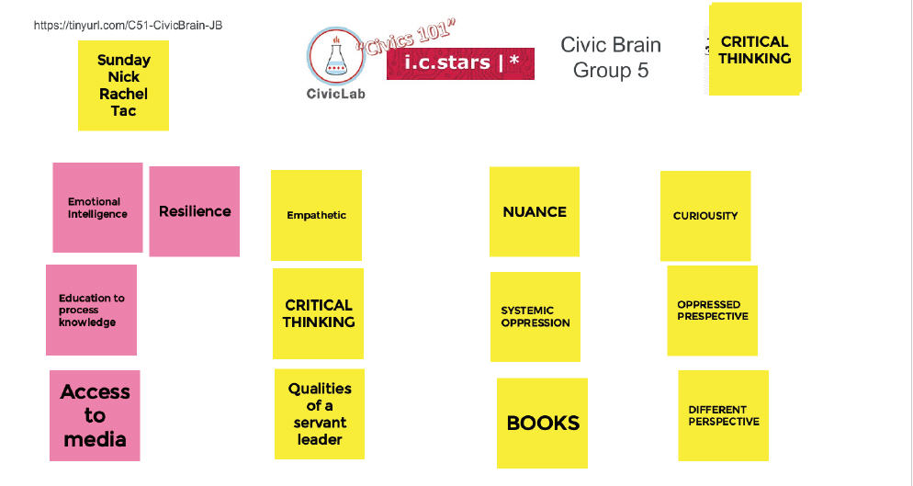

- Class #3 -> Civic Muscle!

