**“Civics 101” Cycle 51 – 10/7/22**

Music – “Na Na Na” My Chemical Romance, by suggested by Anthony - <https://www.youtube.com/watch?v=egG7fiE89IU>

Kahlil Greene, the Gen Z Historial

Interview: <https://www.wbur.org/hereandnow/2022/09/27/gen-z-historian-kahlil-greene> 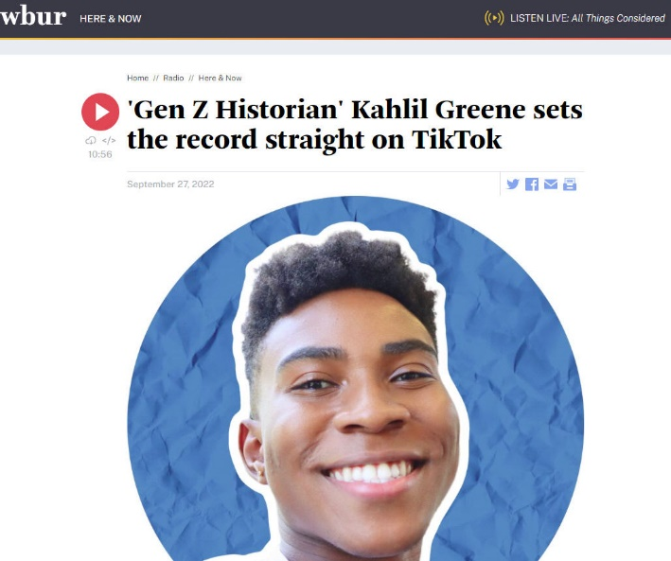

* <https://www.kahlilgreene.com>
* <https://www.instagram.com/kahlil.greene>
* <https://www.tiktok.com/@kahlilgreene>

**Building Our Civic History Muscles**

**-** Activities one might do to increase and upgrade our comprehension of History/Context? - JamBoard at <http://www.tinyurl.com/C51-History>

- Oral history - interview people close to you

- Become your own historian...

- Join book clubs...read more!

- Read/listen from the "concerned group"...

- Who can best speak about their story - the people, themselves...

- People's History Project - Howard Zinn-> <https://www.zinnedproject.org/materials/peoples-history-of-the-united-states>

- Visit museums

- Talk to your family members

- Pressure oppressors to return relics

- Listen to indigenous peoples -> <https://www.fieldmuseum.org/exhibitions/native-truths-our-voices-our-stories>

- Learn about laws - how they impacted

- "Every time an elder passes, a library passes with them"

- Look into history of major colleges - made their starts/early wealth with enslaved peoples...

- Record history - your elders

- “The Price for Their Pound of Flesh” by Daina Ramey Berry

- Engage in community events

- Ask questions from those close to the issue at hand.

- Become a civic reporter... Take a look at Chicago based City Bureau Documenters Program -> <https://www.citybureau.org/documenters-about>

- Nontraditional history books

- Bring historian to class

- View/Share documentaries -> <https://www.complex.com/pop-culture/21st-century-movies-for-social-justice>

- Engage in public events/festivals/celebrations/protests

- Listening to people who have been ignored

- Use the power of the media. Create your own publishing, movies, podcasts, etc.

- Seize the means of cultural production,Become storytellers.

- Even cartoons must be inclusive.

**How about being a Follower?**

- “How To Start a Movement” (5:41)TED Talk by Derk Sivers - <https://sive.rs> –YouTube at <http://www.tinyurl.com/How2StartMovement>

- Need the leader to stand out...to be public - But the first follower is critical!

- It takes courage to stand out. Followers transform you from lone nut...

- The Movement must be public!

- Being a follower is + - but under valued - Being a Follower is an underrated aspect of leadership.

- Being a leader is a function of the permission of the followers. The follower makes the leader possible.

**Civic Muscle: Activities you have done // Accomplishments // Things you have built/run**

- In camp focused on leadership - doing classes, workshops, activities.

- Go into community - listening for needs - giving out supplies.

- Worked with aunt to get charter schools opened - LOT of community organizing required - permissions - land - funding all needed. BIG project! Was part of the effort and it was transformative...

- Working in customer service - in area of unemployment – exposed me to wide range of issues. People calling in crying, with cancer, homeless - hard experience - "I want to help everyone"- It humbled me - made me aware of what I have… Made me want to"be a blessing to others"

- So this reflection sends us back to considering Civic Heart - Back to where is the love - share and love

- Several people mentioned an activity such as interviewing elders to learn about immigration experience.

- As organizers, change agents, champions of justice – we must go on a Personal journey first - relearn history to get grounded…

- Look at Bobbi Harro’s Cycle of Liberation. <https://geography.washington.edu/sites/geography/files/documents/harro-cycle-of-liberation.pdf>