**i c stars Cycle 51 – “Civics 101” – Class #1 – 9/23/22**

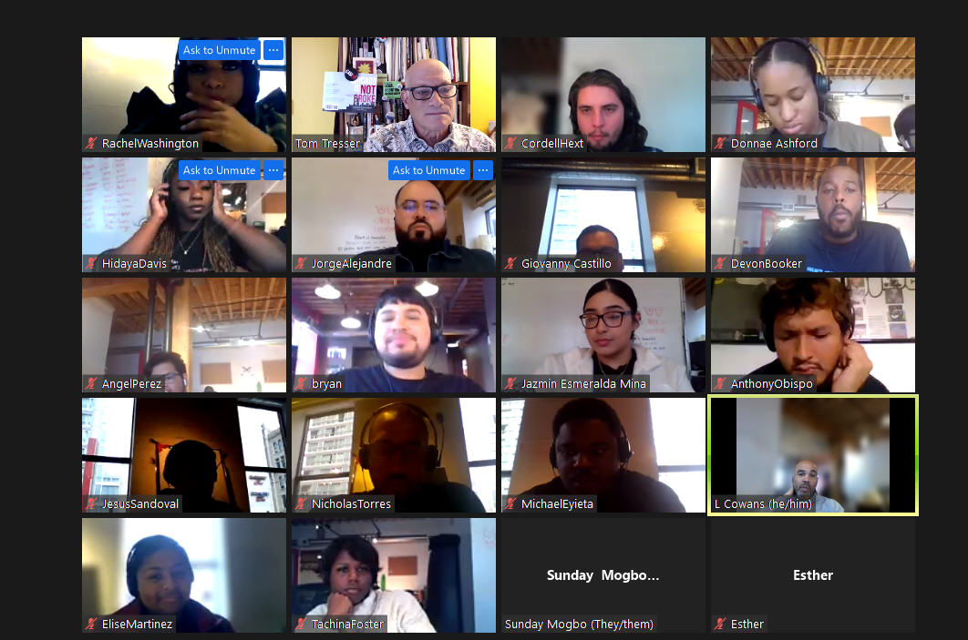

Welcome – Music = “The Party’s Just Begun” by the Cheetah Girls, suggested by Elise.

Please sign in with your name and where you live.

- Tom Tresser, Lincoln Park.

- Rachel Washington - Chicago

- Anthony Obispo, Belmont Cragin

- Jorge Alejandre, Logan Square

- Cordell Hext, Boystown

- Giovanny Castillo or Gio, Chicago Belmont-Cragin

- Devon Booker, Englewood

- Class website: <http://www.civiclabhq.us/i-c-stars-civics-101/cycle-51> - Password = “ICSTARS”

**Why do civics?**

- Need to be a voice in the community - engage – find/restore harmony.

- Voice for your beliefs - to make things better...

- To resolve social issues - push for equity & equality.

- Tech world NEEDS civics!

- Sometimes WE cause and perpetuate problems...

- To understand the differing opinions and learn to respect them

- Action!

- Because, if you DON’T act...

- Most people stand by and watch or take it...Are you a bystander?

- Maybe more people WOULD act if they knew how to start, if they had more time…

**What is your Political Typology? What sorts of beliefs do you start with?**

- Pew Research Quiz at <http://www.tinyurl.com/Pew-Political-Type-C51>

- Please post results at <https://www.surveymonkey.com/r/C51-PT>

- “I’ll Be Loving You Always” by Stevie Wonder, suggested by Rachel - <https://www.youtube.com/watch?v=r_VmbUhNZw0>

- Wording of quiz off? Not perfect but still useful for our purposes

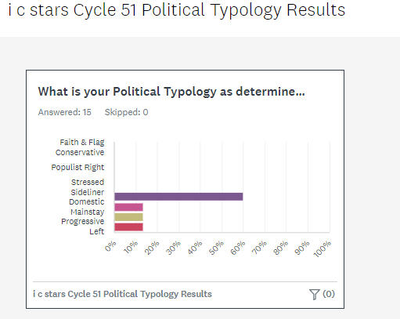

**What is your Burning Issue?**

- Tom - Lincoln Park - Economic injustice

- Abortion rights (2 Interns)

- Climate disaster  
- Exclusion

- Healthcare crisis  
- Gentrification (2 Interns)

- Fractures, divisions in society

- White supremacy <-> capitalism

- Lack of understanding

- Poverty & homelessness

- Financial illiteracy, economic inequity

- Educational inequity (north side vs south side)

- Lack of love/empathy

- Community equity

- Equality

- Opportunity for low-income communities

**Small Group Work – Civic Heart** – Use JamBoard - <https://tinyurl.com/C51-CivicHeart-JB>

- Empathy

- Spirit of rebellion - see right/wrong

- Uplift people

- Respect other views - but NOT ***all*** views?

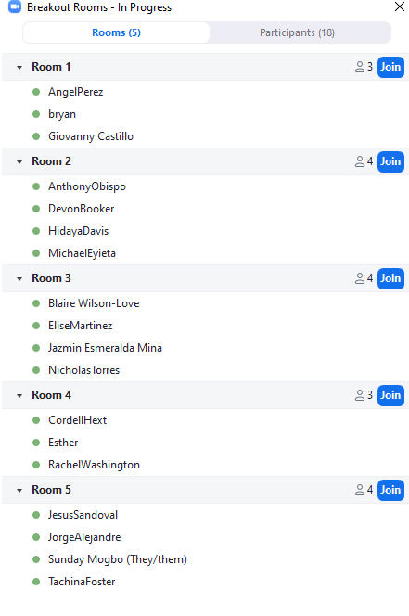- Be aware of "respect" trap - need to have safe spaces - be aware of views harboring/promoting hate...

- What is "extreme"?

- Be open minded - respect still needed...

- Are there any views that must be universal?

- We make war, do evil because we want to - People choose their paths...

- Empathy - most critical

- Desire to push for equity

- Self awareness * Emotional Intelligence

- Must be vocal

- Compassion - love yourself - love others

- Be brave - speaking up - "Taking the knee+ - shake things up - is RISKY

- Openness - good listener - kindness

- Aware of others

- Be loving

- Compassion - see things from other's point of view

- Progressive attitudes

- Push against stagnation - be about change - questioning

- Have civic imagination

- Patience, good communicator

- Have courage – know when to assert/when to step back - being strategic

- Wanting and willing to walk in another's shoes

- Being fearless - OK with risk - lead from the front

- Tom’s way: make the path by walking in

**Top One or Two Traits for Civic Heart?**

- Empathy - came up in all boards

- Love

- Compassion

- Courage – willingness to fight

- Understanding

- Altruism - care for others - Ubuntu